APPLICATION BUILDING

|  |  |
| --- | --- |
| Date | 11 November 2022 |
| Team ID | PNT2022TMID17433 |
| Project Name | AI-Powered Nutrition Analyzer for Fitness Enthusiasts |

1. Home.html

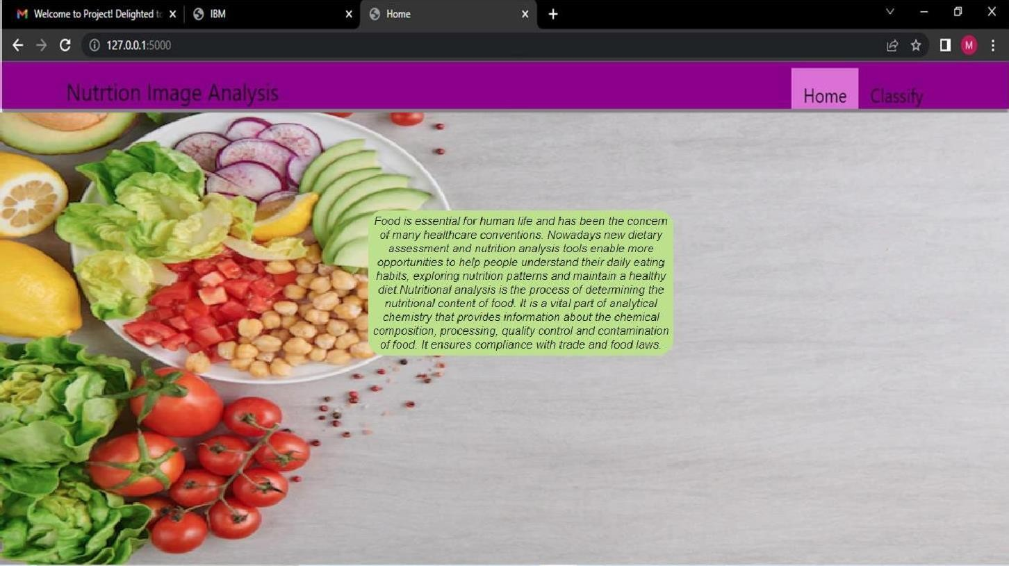

1. Image.html

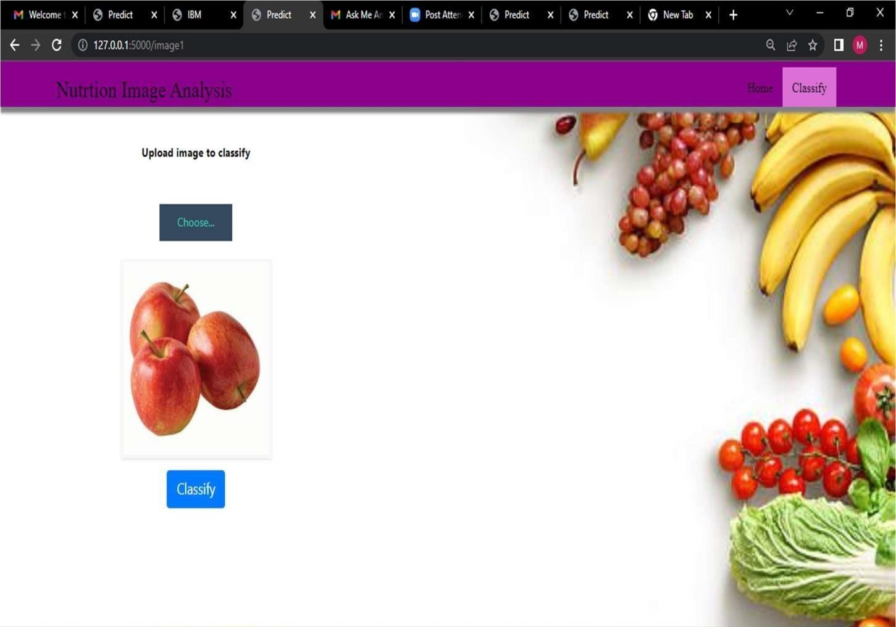

1. Imageprediction.html

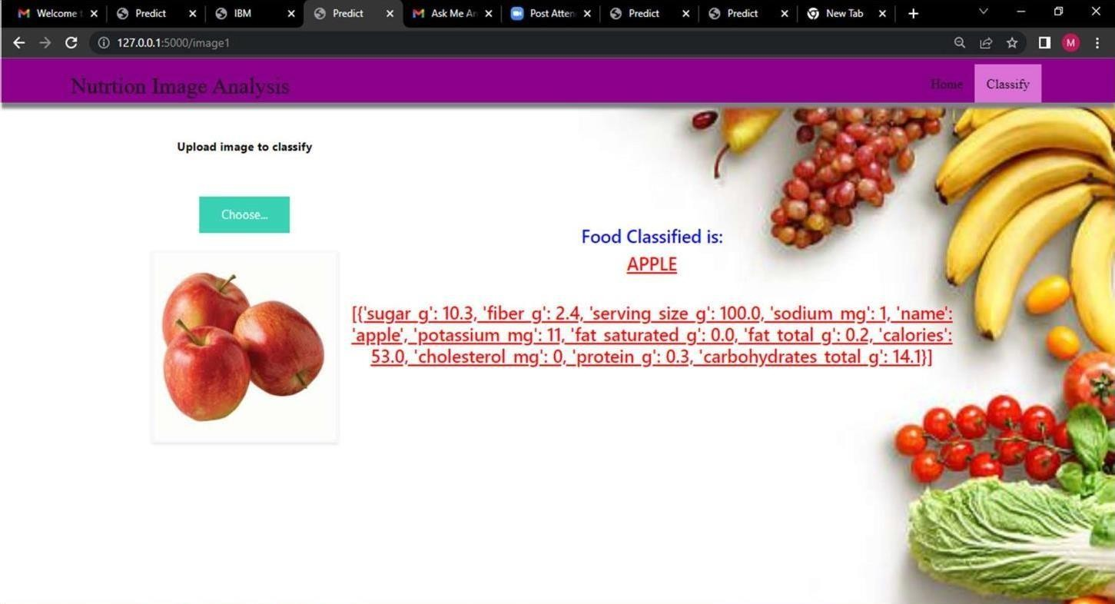

1. Other food classification samples

